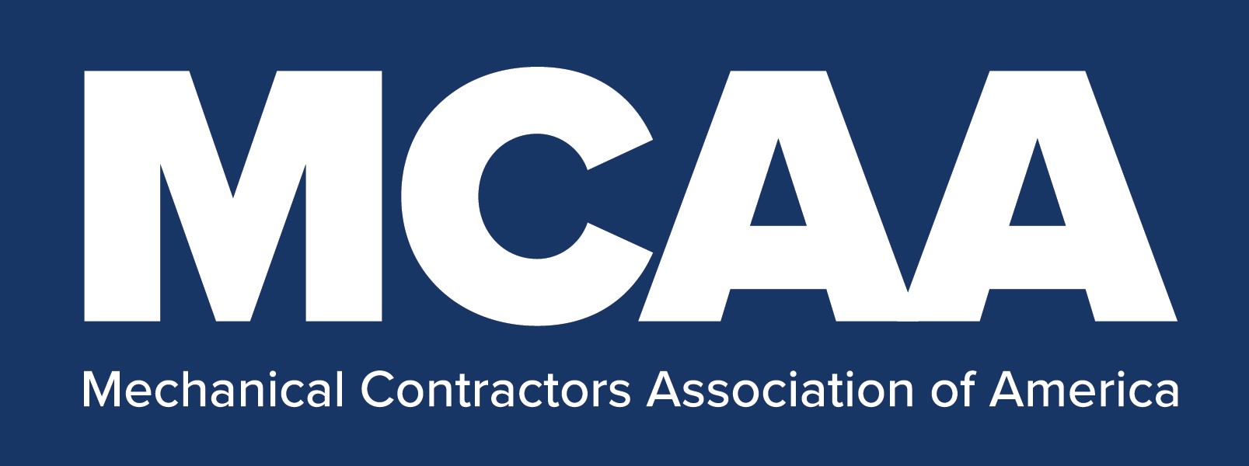

COVID-19 Return to Work Exposure Control Plan
25-Question Multiple Choice Test

COVID-19 Return to Work Exposure Control Plan Test

In this document, you will find a 25-question multiple choice test that corresponds with your company’s COVID-19 Return to Work Exposure Control Plan.

How to Administer Tests to Trainees:

- Make one copy of the test for each trainee.
- Give one test to each trainee. Remind them to put their name on each page in case the pages become separated.
- Collect all test papers after each trainee has completed the test.
- Grade the tests using the corresponding COVID-19 Return to Work Exposure Control Plan Answer Key.
- Return the graded test papers to each trainee. Make sure they understand the correct answers to all the test questions they answered incorrectly.
- Collect all test papers again and place them in a secure file.
- Keep the completed test papers to show proof of worker training and training content understanding.

COVID-19 Return to Work Exposure Control Plan Test

Name:
Directions: Circle the letter corresponding to the best answer for each question.

- COVID-19 is a virus that originates in

  - camels
  - bats
  - mosquitos
  - birds

- The COVID-19 virus spreads by

  - respiratory droplets from a cough or sneeze
  - open cuts or abrasions
  - ingesting contaminated food
  - drinking contaminated water

- The virus enters the human body by way of the

  - lungs (inhalation)
  - eyes (mucus membrane)
  - nose and mouth (mucus membrane)
  - all the above

- Emergency warning symptoms of COVID-19 include

  - cough
  - headache and sore throat.
  - chills, fever of 100.4^{O} F or higher, and new loss of sense of taste or smell
  - shortness of breath, persistent pain or pressure in chest, and new confusion
  - none of the above

- Individuals who are at high risk for severe illness or death if they contract COVID-19 include those who

  - smoke and/or those with a body mass index (BMI) of 40 or higher
  - are 45 years old and older
  - own certain types of exotic pets
  - participate in frequent vigorous exercise

COVID-19 Return to Work Exposure Control Plan Test

Name:

- If you feel sick

  - take ibuprofen, acetaminophen, or some other fever reducing medication
  - avoid working within 6 feet of your coworkers and others on the jobsite
  - Wear a cloth face covering, so that you will not infect others on the jobsite
  - stay home and let your foreman or immediate supervisor know immediately

- Help prevent contracting and spreading COVID-19 by avoiding gatherings of more than _____ people.

  - 5
  - 10
  - 15
  - 20

- Another way to help prevent contracting and spreading the virus is to

  - practice good personal health and hygiene
  - wear a cloth face covering or surgical mask at work and when in public
  - practice appropriate social distancing
  - all the above

- Frequently touched surfaces, such as doorknobs, handles, light switches, telephones, tables, countertops, phones, etc. should be disinfected at least

  - hourly
  - daily
  - weekly
  - monthly

- If you use an alcohol-based disinfectant solution, it should contain at least _____ % alcohol.

  - 60
  - 70
  - 99
  - 100

COVID-19 Return to Work Exposure Control Plan Test

Name:

- As part of practicing good personal health and hygiene you should wash your hands frequently with soap and water for at least _____ seconds.

  - 10
  - 15
  - 20
  - 30

- When your work area in a facility has been recently disinfected, ask the appropriate onsite personnel for _____ to learn about the hazards and protective measures for the disinfectant.

  - a WHO sheet
  - a NIOSH guide
  - an MSDS
  - an SDS

- The minimum appropriate social distance for preventing the spread of, and/or contracting COVID-19 is _____ feet.

  - 5
  - 6
  - 8
  - 10

- When social distancing while working is temporarily unsafe or impractical, you will need to

  - quarantine for 14 days following completion of the task
  - wear additional personal protective equipment (PPE)
  - use hand sanitizer always while performing the task
  - increase ventilation/air circulation in the work area.

- Cloth face coverings are not considered to be

  - respirators
  - personal protective equipment (PPE)
  - protective for handling human waste or sewage
  - all the above

COVID-19 Return to Work Exposure Control Plan Test

Name:

- For higher risk applications, elderly individuals, and individuals with underlying medical conditions, the best protection for the respiratory system, nose and mouth is

  - a cloth face covering or surgical mask
  - a cloth face covering or surgical mask, and a face shield
  - an N95 or N95 type respirator
  - staying at least 6 feet away from everyone else on the jobsite

- Daily jobsite surfaces disinfection includes disinfecting many items, such as

  - radios, elevator buttons, handrails, ladders, and gang box latches and handles
  - hand sanitizer and soap dispensers, light switches, and toilet flush handles
  - door handles, mobile table and cart handles, aerial lift gates-chains, and controls
  - all the above and all other frequently touched surfaces

- In lower risk work applications, where social distancing is temporarily unsafe or impractical be sure to wear safety glasses and

  - a cloth face covering or surgical mask, and nitrile gloves
  - an N95 or N95 type respirator, face shield and nitrile gloves
  - a cloth face covering or surgical mask, face shield, and cut resistant work gloves
  - a splash proof face shield, N95 or N95 type respirator, and nitrile gloves

- When working on HVAC equipment with energized electrical conductors or circuit parts protect yourself first from

  - COVID-19
  - arc flash
  - electrical shock
  - b and c

- When cleaning and disinfecting your tools use

  - turpentine
  - paint thinner
  - a mild soap
  - a strong degreasing soap
COVID-19 Return to Work Exposure Control Plan Test

Name:

- The best product to use for disinfecting your tools is

  - 100% Clorox bleach
  - isopropyl rubbing alcohol
  - soap and hot water
  - the tool manufacturer’s recommended disinfectant

- When cleaning and disinfecting tool batteries

  - wipe down only the exterior surfaces of the batteries
  - wipe down all surfaces of the battery
  - wipe down the entire battery with disinfectant
  - dry the batteries with compressed air

- When working on HVAC equipment with energized electrical conductors or circuit parts near plumbing vents or exhaust fans, wear

  - nitrile gloves instead of electrical protective rubber gloves
  - an N95 respirator under your arc flash face shield
  - a Tyvek suit in place of arc flash protective coveralls
  - none of the above

- When using hand sanitizer, be sure to _____ before going near any potential sources of ignition, including static electricity.

  - sanitize the backs of your hands, fingernails, and between your fingers/thumb
  - use a sanitizer with 10% alcohol or less
  - let the sanitizer evaporate completely
  - disinfect the potential sources of ignition

- Individuals who are ____ years old or older are considered to be at high risk for severe health issues from COVID-19.

  - 40
  - 50
  - 60
  - 70

