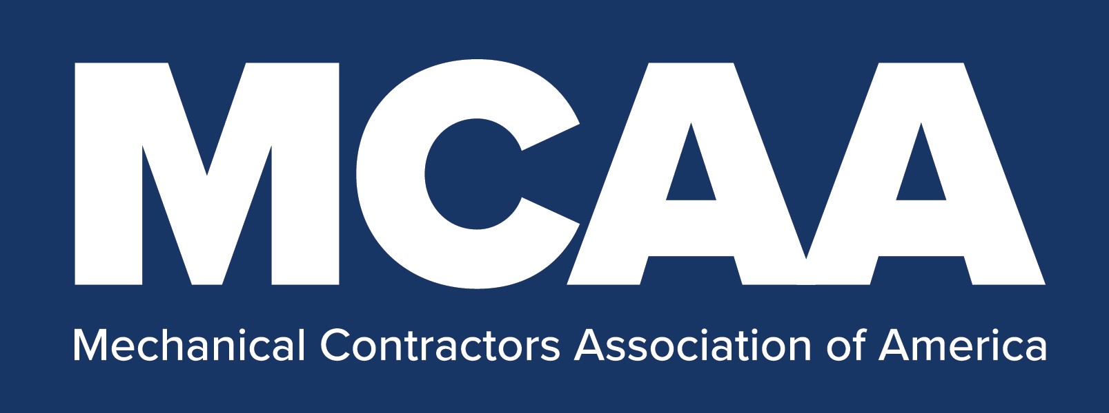
COVID-19 Jobsite Screening Questionnaire

<COMPANY LETTERHEAD>
COVID-19 Jobsite Screening Questionnaire

<Jobsite Name, Address and Date>
<Customer’s Primary Contact Name, Mobile Phone, and E-mail Address>

<Company> is making every effort to effectively control its workers’ exposure to COVID-19. As part of our exposure control plan, <company> requests that you complete the following questions and return the completed form to <name and phone number> at
<e-mail> by <date>.

- Is <Customer Name> currently implementing a site-specific COVID-19 Exposure Control Plan? Yes___ No___

- Are all personnel returning to this jobsite screened based on the last 14 days for out of country travel, domestic travel through large city airports, contact with others who have been diagnosed with COVID-19, or have symptoms of the virus, and existing COVID-19 symptoms? Yes___ No___

- Are all personnel who work at this jobsite screened <daily> before starting work for a body temperature of <100.4º F> or higher and asked to self-identify if other existing COVID-19 symptoms exist? Yes___ No___

- Are all personnel who work at this jobsite required to stay off the jobsite if they test positive for COVID-19, or experience a fever of <100.4º F> or higher, chills, cough, shortness of breath or difficulty breathing, muscle or body aches, headache, new loss of taste or smell, sore throat, congestion or runny nose, nausea or vomiting, or diarrhea. Yes___ No___

- Are hand washing or hand sanitizing facilities readily accessible? Yes___ No___

- Are all personnel working at this jobsite required to follow appropriate personal hygiene practices to help prevent the spread of COVID-19? Yes___ No___

- Are all frequently touched surfaces at this jobsite disinfected at least daily with a chemical disinfectant that is effective against COVID-19? Yes___ No___

- Are all personnel working at this jobsite required to wear the appropriate personal protective equipment based on COVID-19 risk levels? Yes___ No___

- Are all low risk personnel working at this jobsite required to always wear a cloth face covering or surgical mask? Yes___ No___

