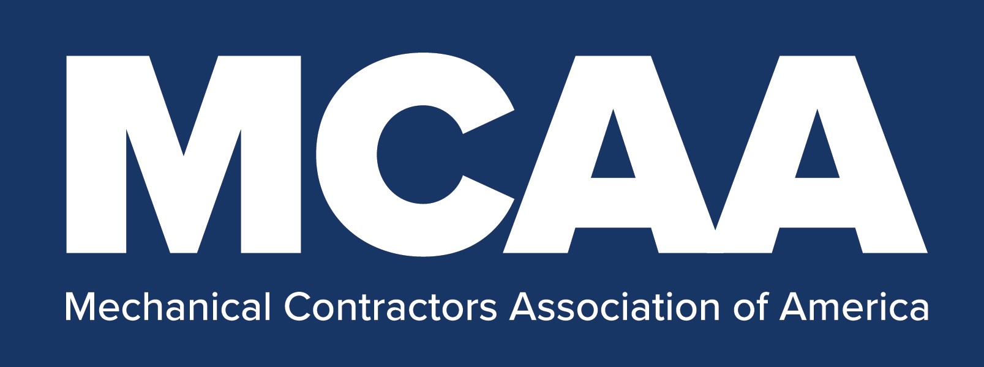
COVID-19 Return to Work Exposure
Control Plan – Checklist

<Date>

<Company>

<Jobsite Name and Address>

<COVID-19 Response Team Member Completing Checklist Name and Mobile Phone Number>

CHECKLIST:

___ COVID-19 Response Team Established
___ Responsibilities Communicated/Understood
___ Local Critical Industries Requirements
Considered
___ Owner, GC, CM, etc. Requirements Considered
___ Most Current CDC Guidelines Considered
___ Exposure Control Plan Tailored Accordingly
___ Jobsite Screening Questionnaire Tailored
___ Prior to Return Jobsite Screening Performed
___ Employee Confidentiality Requirements
Established
___ COVID-19 Screening Questionnaire Tailored
___ Prior to Return Employee Screening Performed
___ Legal Counsel Consulted Re: <Daily> Screening
___ Thermometer/Thermometer Parts Supply
Adequate
___ 3rd Party Screener Identified/Retained
___ Another Screener Identified/Trained
___ Screener Properly Supplied & PPE Outfitted
___ <Daily> Employee Screening Established
___ <Daily> Employee Screening Documented
___ Visitor Protocol Communicated
___ Material Delivery-Ship/Rec. Protocol
Communicated
___ Jobsite Communication Established
___ Supervisor Training Completed
___ All Other Employees’ Training Completed

___ Hand Washing/Sanitizing Means Established
___ Adequate Supply of Soap/Sanitizer on Site
___ Social Distancing Enforcement Protocol Established
___ Cloth Face Coverings/Surgical Masks Supply
Adequate
___ Cloth Face Coverings/Surgical Mask Cleaning
Protocol Established
___ Face Shield Supply Adequate
___ Safety Glasses Supply Adequate
___ Safety Goggles Supply Adequate
___ Nitrile Gloves Supply Adequate
___ Protective Suit/Coverall Supply Adequate
___ Cut-resistant Work Glove Supply Adequate
___ Splash-Proof Face Shield Supply Adequate
___ Liquid-repellant Coverall Supply Adequate
___ Rubber Outer Glove Supply Adequate
___ N95/Approved Equivalent Supply Adequate
___ N95/Approved Equivalent Locked Up/Secured
___ Rubber Boots Supply Adequate
___ Surfaces Disinfectant Supply Adequate
___ Tool Cleaning Soap Supply Adequate
___ Tool Cleaning Disinfectant Supply Adequate
___ PPE Decontamination Bag Supply Adequate
___ Subcontractors’ Requirements Communicated
___ Subcontractors Provided with Copy of Plan
___ Subcontractors Completed Plan Approved
___ Labor Counsel Consulted Re: Bargaining
___ Bargaining Agent Consulted
___ Bargaining Unit Workers’ Rep Notified

